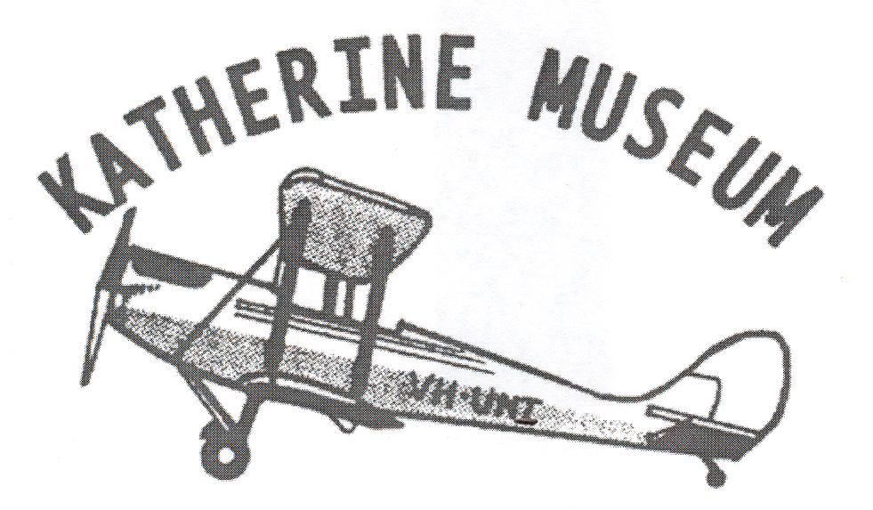
Accession Number:
Date:

Historical Society of Katherine
Katherine Museum
PO Box 93
Lot 2922 Gorge Road
Katherine NT 0851

Receipt for purpose of

- Donation Form

The Historical Society of Katherine Inc acknowledges receipt of the items described and listed below from:

Acquired from:

Name___________________________________
Address_________________________________
Telephone ______________________________
Email __________________________________
________________________________________________

ITEMS
1/_______________________________________________
2/_______________________________________________
3/_______________________________________________
4/_______________________________________________
5/_______________________________________________
6/_______________________________________________

§
Signed on behalf of ________________ Historical Society of Katherine.
Source (Acquired from)___________________Date _________
Date: __________________________________

Deed of gift with transfer of Ownership

I declare that I am the owner /or acting on behalf of the owner with full rights of owner.

I / We the undersigned hereby donate, without retaining any right of revocation, the item or items described on the receipt form, to the Historical Society of Katherine Inc, and in doing so confirm that I/we are the unencumbered owner(s) of that item(s).

I/We recognise that this donation will cause a transfer of ownership and all intellectual property rights associated with the item(s). I/We also acknowledge that the Historical Society of Katherine Inc. will, on receipt of the item(s) specified have absolute right to display or otherwise deal with it/them at its own discretion.

This Form is a deed of Gift

Signed ............................................... Date ......................Staff Officer ................................

Witness ............................................... Date.......................Date .................................

Permission for use (Donations and Photographs/Documents)

The items described in receipt form may be copied for private use of the public; displayed; published; or used for research by this organization without further permission being sought. Acknowledgement will be given to donor or owner in external exhibition and publications.
Restrictions (if any)-___________________________________________________________________________________

___________________________________________________________________________________

Signed ................................................. Date .......................Staff Officer...............................

Witness ................................................ Date .......................Date ...............................

Administration of Loan Photographs/ Documents
Original photographs returned to owner

Date_________________

Signature Owner or Agent____________________

Office Use Checklist

Copy given to Dona
Permission for use signed

Letter sent from Mosaic Database

